www.nefertiti-h2020.eu
nefertiti.eu
Nefertiti
@nefertiti_eu
europe@acta.asso.fr
FarmDemo Channel

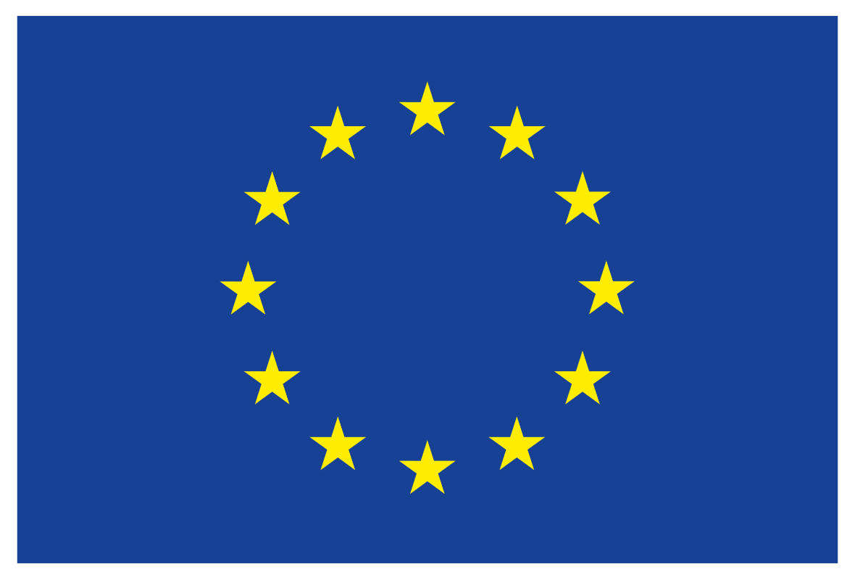

This project had received funding from the European Union’s Horizon 2020 research and innovation programme under grant agreement N°772705

PRESS RELEASE for type of the demo event
(please write the type of the demo event - seminar, demonstration, open field day, workshop, conference, training session, field trip, etc.)

Title of the demo event
Held on date of demo event

On date of demo event a type of the demo event was organised: type of the demo event. The type of demo event was organized by demo event organizer(s). The event was attended by xxx participants.
They were ………………………………………………………………………………………………. (please describe type of participants).

If it is relevant: The event was organized in the name of host farm/location.

The purpose of the type of the demo event was to ..........................................................
The type of the demo event covered the following main topics:
• ....................................................................................................................................................................
• ....................................................................................................................................................................

The topics were demonstrated by ...............................................................................................
...........................................................................................................................................................................
During the event, the greatest interest was caused by ...................................................

...........................................................................................................................................................................

Photos of the event:

The event was organized under Horizon 2020 NEFERTITI project, by name of hub within Network number of the network “Title of the network”. NEFERTITI is a unique Network (selected under Programme Horizon 2020) comprising 32 partners and is coordinated by ACTA. The 4-year project will finish on the September, 30th 2022. The overall objective of NEFERTITI is to establish an EU-wide highly connected network of well-specified demonstration and pilot farms designed to enhance knowledge exchanges, cross fertilisation among actors and efficient innovation uptake in the farming sector through peer-to-peer demonstration of techniques. 10 interactive thematic networks are being created, bringing together 45 regional clusters (hubs) of demo-farmers and actors involved (advisors, NGOs, industry, education, researchers and policy makers) in 17 countries. Additional information can be found on the project website: www.nefertiti-h2020.eu.

The main objectives of Network number of network are ..............................................
..........................................................................................................................................................................
More information on the hub members and activities can be found at: Link to the hub-page on the platform

