Network icon | 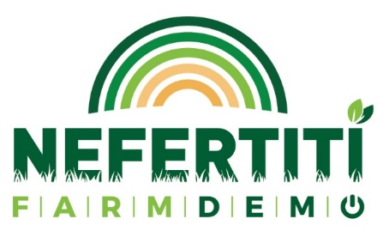 | FLAG

PRESS RELEASE
for
[type of the demo event]
(please write the type of the demo event - seminar, demonstration, open field day, workshop, conference, training session, field trip, etc.)

„ [title of the demo event] “

held on [date of demo event]

On [date of demo event] a [type of the demo event] was organised: “[title of the demo event]”. The [type of the demo event] was organized by [demo event organizer(s)]. The event was attended by …… participants. They were …………………. (please describe type of participants).
If it is relevant: The event was organized in the [name of host farm/location].
The purpose of the [type of the demo event] was to ……………………………………………….
The [type of the demo event] covered the following main topics:
- …………….
- …………………;

The topics were demonstrated by ………………………………………………………………

During the event, the greatest interest was caused by ………………………………………

Photos of the event:

The event was organized under Horizon 2020 NEFERTITI project, by [name of hub] within Network [number of network] “[title of the network]”. NEFERTITI is a unique Network (selected under Programme Horizon 2020) comprising 32 partners and is coordinated by ACTA. The 4-year project will finish on the 31st December 2021. The overall objective of NEFERTITI is to establish an EU-wide highly connected network of well-specified demonstration and pilot farms designed to enhance knowledge exchanges, cross fertilisation among actors and efficient innovation uptake in the farming sector through peer-to-peer demonstration of techniques. 10 interactive thematic networks are being created, bringing together 45 regional clusters (hubs) of demo-farmers and actors involved (advisors, NGOs, industry, education, researchers and policy makers) in 17 countries. Additional information can be found on the project website: www.nefertiti-h2020.eu.
The main objectives of Network [number of network] are …………………………………………. More information on the hub members and activities can be found at: [Link to the hub-page on the platform ]

