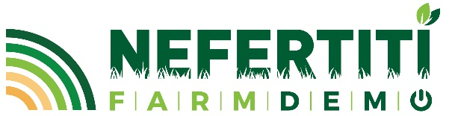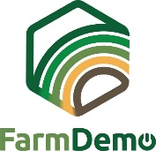
Consent Form
Video recordings for H2020 NEFERTITI
By signing this document, I understand that the [Event type] on the [Date] at [location]
is part of the project NEFERTITI: Networking European Farms to Enhance Cross Fertilisation and Innovation Uptake Through demonstration.
I understand that the interactions between participants of the event may be observed and captured by video and other digital recording devices.
I understand that these recordings can be used for educational purposes, e.g. the development of courses or information videos for widespread use on [topic of the event].
I understand that these recordings can be analyzed by the researchers involved in the NEFERTITI project to understand (peer) learning processes between participants of the event and to increase the knowledge on [topic of the event].
In addition, I understand that these recordings will be shared with the project partners of NEFERTITI and will be stored on a password protected sharepoint. I understand that individual names will not appear in any report or publication resulting from this study.
I authorize the use of such data and recordings as described above only for the scientific and educational purposes specified above.
I know that during this project, I am free to withdraw my consent and decline the recordings at any time, and that no penalty or prejudice shall result.
You are required to sign a copy of this consent form should you agree. Thank you for considering taking part in this study.
Further questions about this project are welcome and should be addressed to:
[Name of the responsible person] – [e-mail address of the responsible person]

_____________________________ ____________________________
(Signature) (Date)

